Suplementary Material

Long-term changes in population dynamics and life history contribute to explain the resilience of a stock of *Micropogonias furnieri* (Sciaenidae, Teleostei) in the SW Atlantic.

**Authors**

Manuel Haimovici1, Leticia Maria Cavole2, Jason M. Cope³, Luís Gustavo Cardoso1

3.5 Mortality and exploitation rate changes

In the Figure 1 it is possible to see all the plots for the Bayesian alternative to the t test performed with the library BEST (Kruschke and Meredith, 2020).

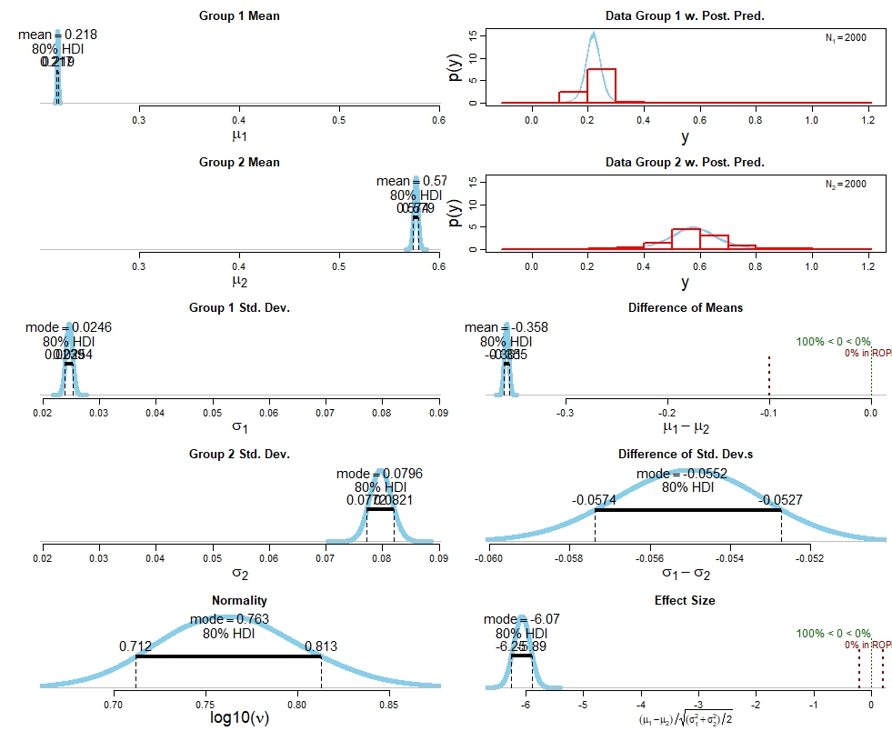

Figure 1. Plots for the Bayesian alternative to the t test performed with the library BEST (Kruschke and Meredith, 2020). Group 1: Estimated Z values for the period 1976-1980 and Group 2: Estimated Z values for the period 2014-2017.

Reference

Kruschke, J.K. and Meredith, M. 2020. BEST: Bayesian Estimation Supersedes the t-Test. R package version 0.5.2. https://CRAN.R-project.org/package=BEST